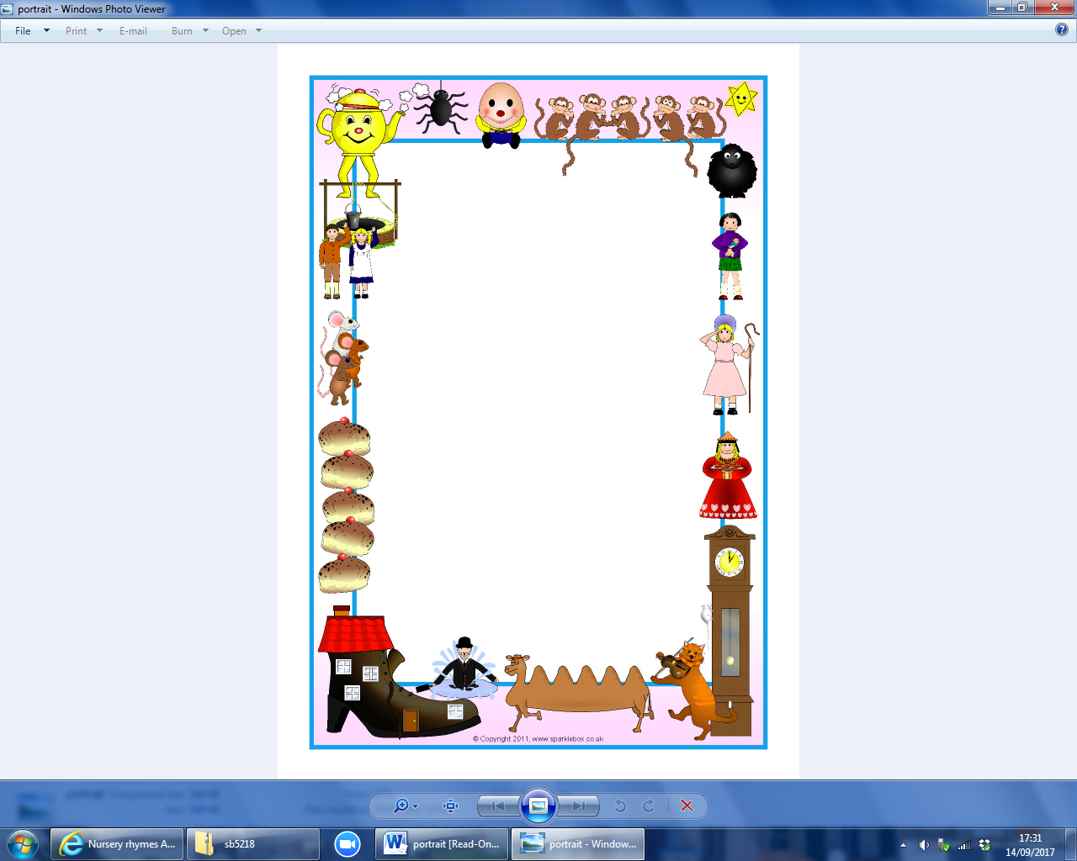

**Welcome to FS1**

Hello and welcome to FS1.

We now have lots of children in FS1. We are always busy and we love learning!

The adults in the unit are: Mrs Hawes – Class Teacher. Mrs Mitchell – Nursery Nurse. Miss Reynolds – Teaching Assistant.

We often spend time with the FS2 children in their unit, where we have snack and a drink if we choose. We also get to play outside which everyone enjoys.

We have a very busy and exciting term ahead. We are doing some lovely work involving nursery rhymes. You might have noticed our Incy Wincy spiders! We also have Scruff and Ben, our weekend dogs who will be coming home to stay with you soon.

We will also be having weekly library books which we will change on Fridays.

Thank you for your support,

The FS1 Team