As always, here at Brinsworth Whitehill Primary School, we are trying to give your children and you as families a fulfilling and fun educational experience.
We constantly strive to make sure your children get the most out of their time in school, and we are always looking to develop and grow as a school.
Here are just a few of the more recent things we have tried to do to enhance everyone’s experience at our school.
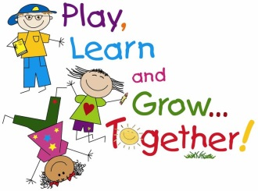
Welcome and Care
Recent events have included our Genes for Jeans and Macmillan fundraising events, our disco and our cultural and religious celebrations in the form of the Harvest Festival, the lovely Eid party, and the family Diwali sharing opportunity. It is lovely that these events attract all kinds of groups of people from our school community and we are looking forward to lots of wonderful fun at Christmas time together.
We are currently looking at further ways that parents and carers can be involved in consultation processes. You will hear more about this soon.
Mrs Lee has introduced ‘Head’s High Tea’. This will be an opportunity for you to celebrate your child’s success with Mrs Lee and your child and to enjoy buns and a drink with them. It will be arranged for children who have received a certain number of wow cards and as we are sure you are aware, these are given for all manner of lovely reasons including caring, good work, demonstrating values like resilience amongst many other possible reasons.
This event will take place on Tuesday November 7th or Thursday November 9th at 2.30pm.. Children will be invited on the last Friday of term.
Our platinum awards are now linked with respect – listen out for the children who receive these lovely awards for this wonderful reason, in assembly.

Communication
We try to listen to children and parent’s concerns calmly and respectfully and review any meetings if necessary, regularly. You should always find that if you leave a telephone message, you will get a response within 24 hours. The policy of our school is that for parents with any concerns, however small they think it might be, go initially to the child’s class teacher and if they still need to talk further they would follow this up by arranging to meet a member of the Senior Leadership Team.
Our website is relatively new but is evolving. We are trying hard to make sure it is informative and useful to you all. There’s lots of information on there – check it out!
There is now a new email system. You may need to bear with us initially whilst any teething problems are ironed out but hopefully you will find it useful and helpful.
Look out for the up-coming opportunity to consult with us and share your voice.

Something new – Chill n Chat
After half term, there will now be a Chill and Chat session which parents can come along to on Friday afternoons between 2 and 3pm in the Community room. It has been arranged at this time so that you can attend around coming to Celebrations assembly for your child. Tea and coffee – and who knows – maybe biscuits, will be available and the idea is that you relax and chat and have your chance to give your very important Parent Voice to what we are doing at school. When possible we hope that Nicola, Fakhara and Sue (our parent charter champions) will be there to chat with you if possible and there should be a member of the school staff there too. Please come along and share your voice.
Value and include
As you know we have an open-door policy throughout our school. Teachers are happy to speak to parents who have concerns of any kind and will always endeavour to do this either straight away or as soon as possible. We are in the process of parent consultations at the moment which are now longer and have both day-time and evening opportunities for you to meet with your children’s teachers. We hope you take this important opportunity to talk about your child’s learning and life in general.
Staff try to respond to the individual needs of children and families quickly and we are always looking for ways to improve learning and give a fulfilling education to your children.
Partnership
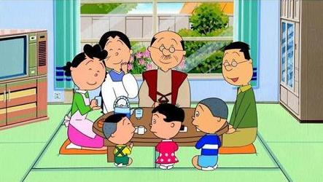
We work in partnership with you as families and also with the Wickersley Partnership Trust. Your children are benefitting from expert teaching in French, Music and PE at the moment.
Our Charter group is meeting behind the scenes to look at more ways to involve everyone in the life of the school and to develop our lovely atmosphere even further by involving more people in school life.
As part of our dedication to working in partnership, the Charter Champion parents are visiting other schools to find out about more good practise and our team is looking to expand. Our vision is to involve lots and lots of people in lots of different ways in our school. We hope you will join with us in any way you wish, to make our school and even more happy and successful school than it already is!
Mrs Wildgoose is our wonderful coordinator of the Friends of Whitehill. We are aiming for our Charter parents to link with them in encouraging lots more people to share their talents, time, energy and enthusiasm with the children and staff at our school. Another letter will follow this one very soon to tell you of the plans we have and ways that you can help. Any time you can spare or talent you can share will help to make your children’s experience at school better. It will be greatly appreciated, and we hope, fun for you!

Thank you for your support
Mrs K Sprague
Parent Charter Coordinator

