Foundation 2 Home Learning Topic Ideas
Summer Term 2 Week 5 (06.07.20) Holidays

Expressive Arts & Design (To experiment with texture, colour and design).

On a sunny day, place some toys on to large sheets of paper and draw around the shadows made by the toys.

We all love to blow bubbles but how about making a bubble snake. Just follow the tips on the picture and see how long you can make your bubble snake!
Share your photos with us...who can make the longest or the most colourful snake??
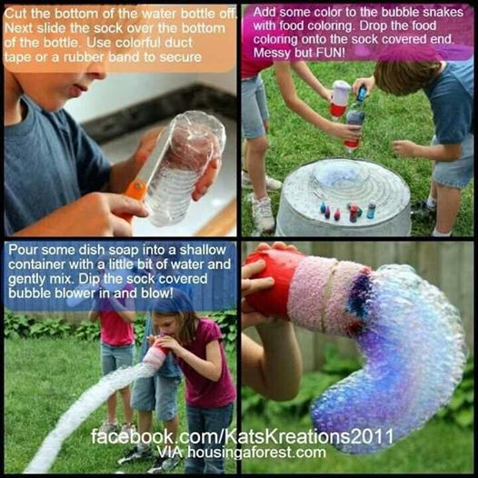

Understanding the World (To make observations of plants and explain why some things occur, and talk about changes).
Can you go on a signs of Summer walk and spot anything that shows you it is now Summer. What can you see? What can you hear? What is it called? What does it feel like?

Physical Development (To move confidently in a range of ways, safely negotiating space).
Can you use chalk to draw some summer pictures in your outside area.
Try some water painting. Dip paint brushes into pots of water and use large and small movements to paint on to a dry pavement/fence.
Can you play a game of ‘stand on a shadow’, where you try to jump on mummy’s, daddy’s, your brother’s or your sister’s shadows?

Extra-Fun National/International Days
July 1st-International Joke day-Share your funny jokes with us!
July 3rd-National Eat your Beans day- Show us how you eat your beans!

